Strengthening the civic commitment of young people
through a Peer led community initiative.

PARTICIPATORY GUIDE FOR YOUNG PEOPLE’S INVOLVMENT
IN EUROPEAN DEMOCRATIC PROCESSES

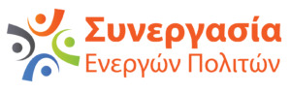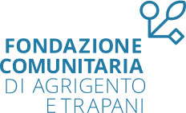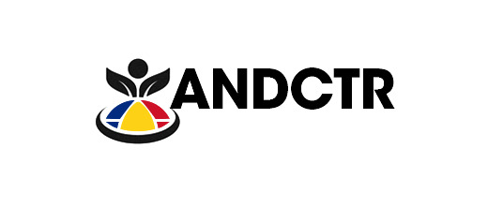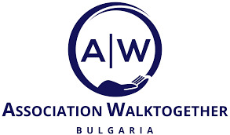

Engagement between young people and their European elected representatives in Italy involves various channels and initiatives aimed at fostering dialogue, participation, and representation. A sample of the primary channels is provided below.

Youth Councils and Organisations
Youth councils and organisations play a vital role in facilitating engagement between young people and their elected representatives. These groups often organise events, workshops, and campaigns to educate young people about the European Union (EU) and its institutions, as well as to encourage active participation in democratic processes.
Youth Council of Italy (Consiglio Nazionale Giovani) https://consiglionazionalegiovani.it/
Italian Youth Agency (Agenzia Italiana per la Gioventù) https://agenziagioventu.gov.it/

Educational Initiatives
Educational initiatives, such as school programmes and university courses, provide opportunities for young people to learn about the EU, its institutions, policies, and the role of elected representatives. These initiatives may include guest lectures, seminars, and study trips to EU institutions.
Eurodesk https://www.eurodesk.it/
Youth Portal (Portale dei Giovani) https://www.portaledeigiovani.it/
Service Civil International Italy (SCI) https://sci-italia.it/
eTwinning https://etwinning.indire.it/

Youth Parliaments
Youth parliaments offer young people a platform to voice their opinions, debate issues, and propose solutions to policymakers. Elected representatives often participate in youth parliament sessions, engaging directly with young people and listening to their concerns.
European Youth Parliament Italy https://www.eypitaly.org/
Youth HUB (Parlamento europeo) https://youth.europarl.europa.eu/it/home.html

Youth Consultations
Elected representatives may organise consultations specifically targeted at young people to gather their input on EU policies and initiatives. These consultations can take various forms, such as surveys, focus groups, or town hall meetings, allowing young people to express their views and contribute to decision-making processes.
Youth Council of Italy (Consiglio Nazionale Giovani) https://consiglionazionalegiovani.it/
University Youth in Parliament (Giovani universitari in Parlamento) https://www.giovaniuniversitariparlamento.it/

Online Platforms and Social Media
Elected representatives often use online platforms and social media channels to engage with young people. This may include hosting Q&A sessions, sharing information about EU policies and initiatives, and encouraging young people to participate in online discussions and debates.
https://www.instagram.com/europeanparliament/
https://www.tiktok.com/discover/european-politics?lang=en
https://www.instagram.com/eypitaly?igsh=dGk3NnB6ZDg2MjE4

Youth Exchanges and Erasmus+ Programmes
Youth exchanges and Erasmus+ programmes provide opportunities for young people from different European countries to come together, exchange ideas, and learn from each other's experiences. These programmes can help foster a sense of European identity and encourage active citizenship among young people.
Mobilities in Italy https://erasmus-plus.ec.europa.eu/it
Europass https://europass.europa.eu/it
Inter Rail https://www.interrail.eu/it/system/404
Youth Portal (Portale dei Giovani) https://www.portaledeigiovani.it/
European Youth Portal (Portale europeo per i giovani) https://youth.europa.eu/home_it
Service Civil International Italy (SCI) https://sci-italia.it/

Overall, the process of engagement between young people and their European elected representatives in Italy involves a combination of formal and informal channels aimed at promoting youth participation, representation, and empowerment within the EU.

